Sevenoaks Chronicle, 17th October 1986
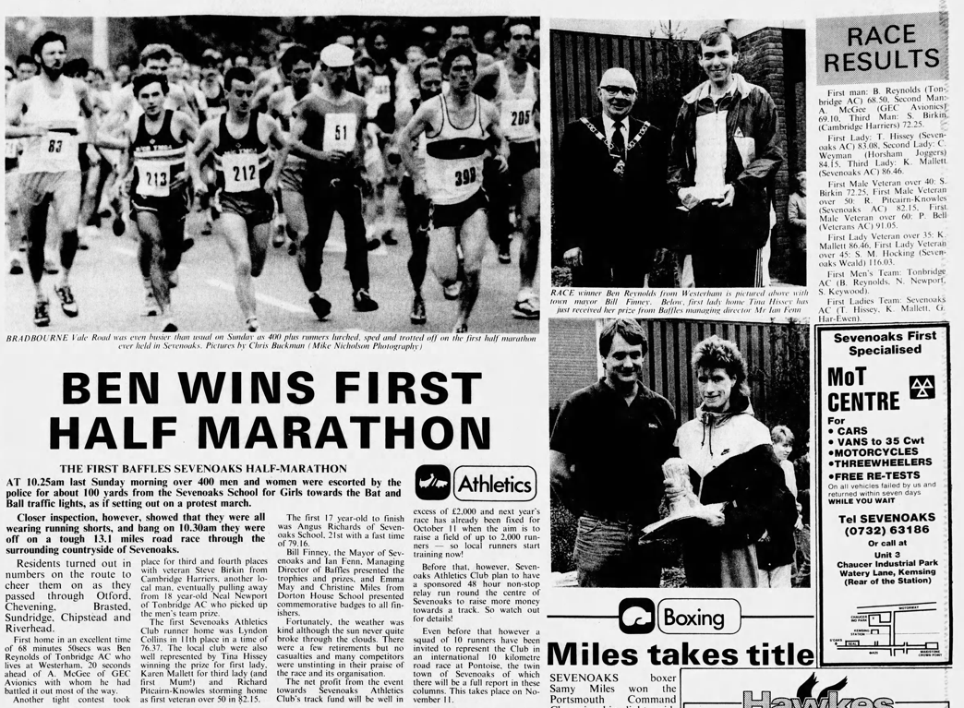
Won by local runner Ben Reynolds from Westerham, representing TAC.
First woman was Tina Oldershaw (nee Hissey) formerly of SAC, more recently PWAC and TAC.
The HM was used as a fund-raising event for SAC getting their own track built. However, as we know, the former cinder track at Sevenoaks School was upgraded to a rubberised track in the late 1990s, after which it became our defacto HQ. Chris Rowley was instrumental in getting the club access with this, purchasing the containers for both the school and club to store our equipment. As a result of these fund-raising activities, the club amassed significant funds, which to this day are earmarked for a club house.

Page 2 – Will Witt at 1st Sevenoaks Half Marathon – photo purchased in his personal archive. Not visible from the photo resolution is that his company Pentacon Projects sponsored the race with the company logo on the number, hence his No.1 bib!
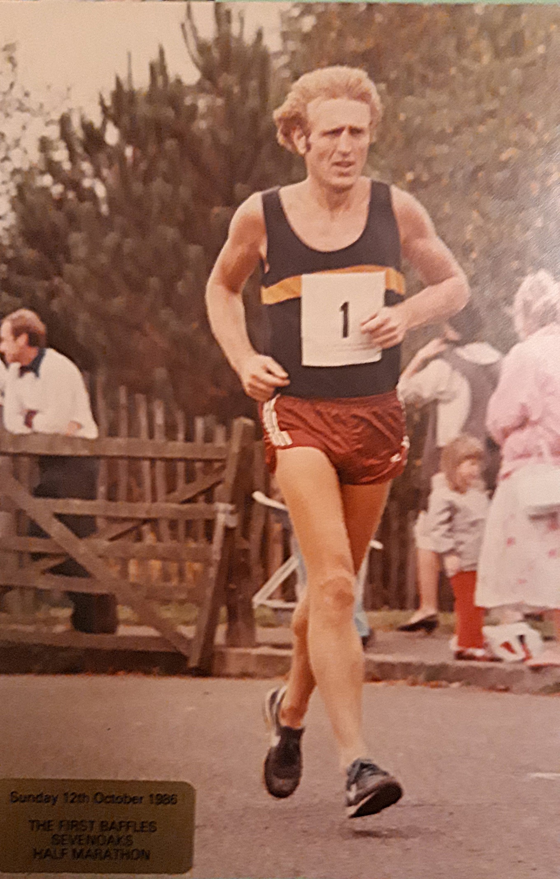
Sevenoaks Chronicle 16th October 1987
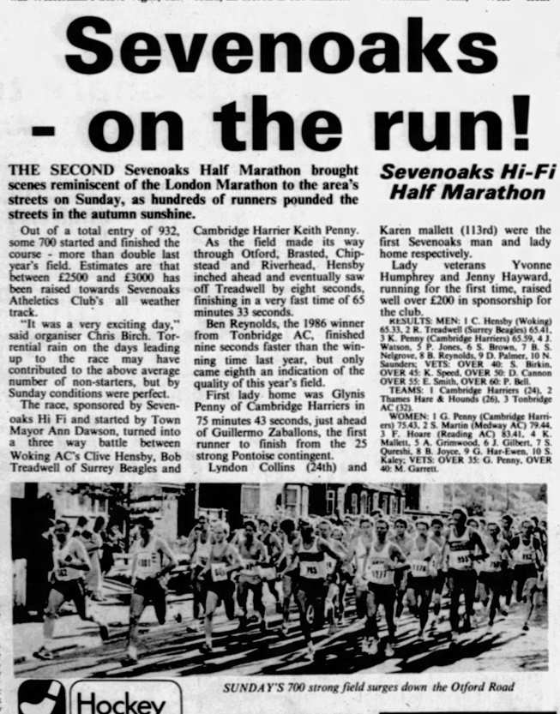
2nd edition of the race, only a week before the famous Hurricane that saw so much damage and destruction of trees in the area, which surely would’ve put paid to the race had it happened on the same weekend?
Lyndon Collins was first home from SAC, Karen Mallet first club lady home.
Sevenoaks Chronicle 2nd September 1988
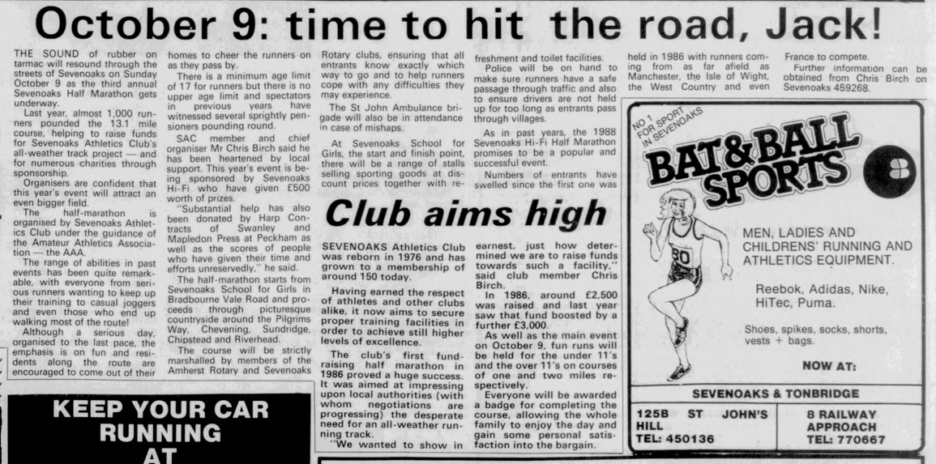

Interesting background on the organisation of the race plus that nugget of information regarding the inception of the current club in 1976!
Seems safe to assume the race raised £2,500 to £3,000 per year for the 8 years it was ‘run’, safely earning the club over £20,000 in savings.

Sevenoaks Chronicle 21st October 1988
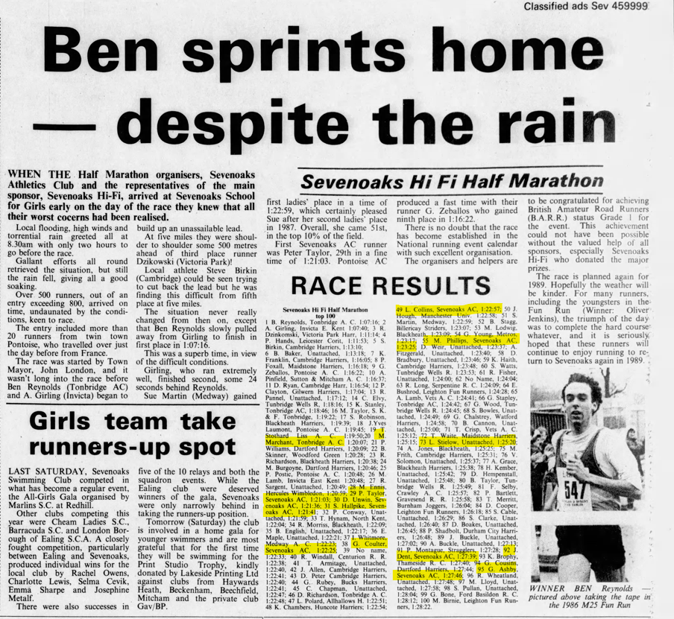
So, the weather wasn’t so kind the following year!
Some fantastic performances by previous and current SAC members! Ben Reynolds winning again with Sue Martin from Medway first woman home.
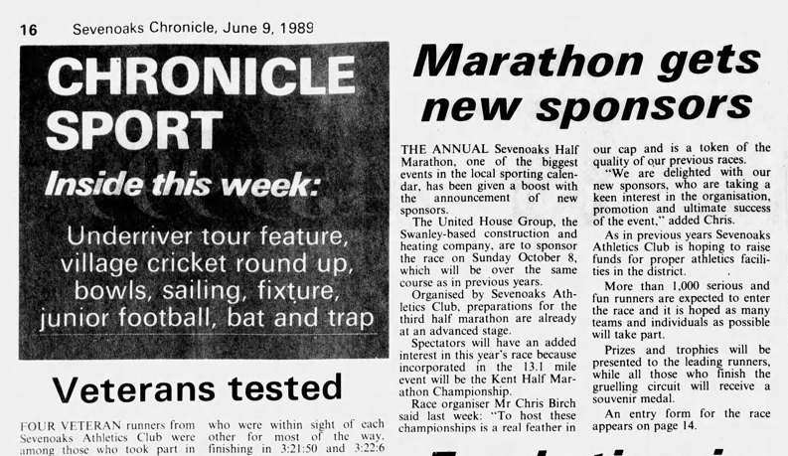Name the club members! I can only get Geoff Vine and Will Witt…maybe Allan Lee and John Denyer are in there? Answers on a postcard to the usual address!
Postscript: Simon Hallpike confirms the following: that’s me on the left, and I think Arthur Holmes is next to me. Also, from right to left: David Simpson, Gerald Ashby, (Witt Snr), Mike Harwood, John Dalziel. The rest of the group around Geoffo, I don't recognise from the photo.

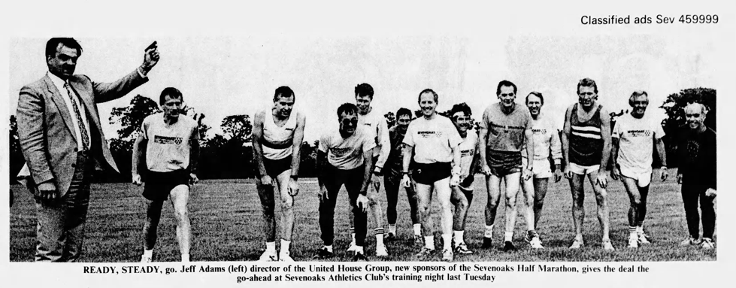
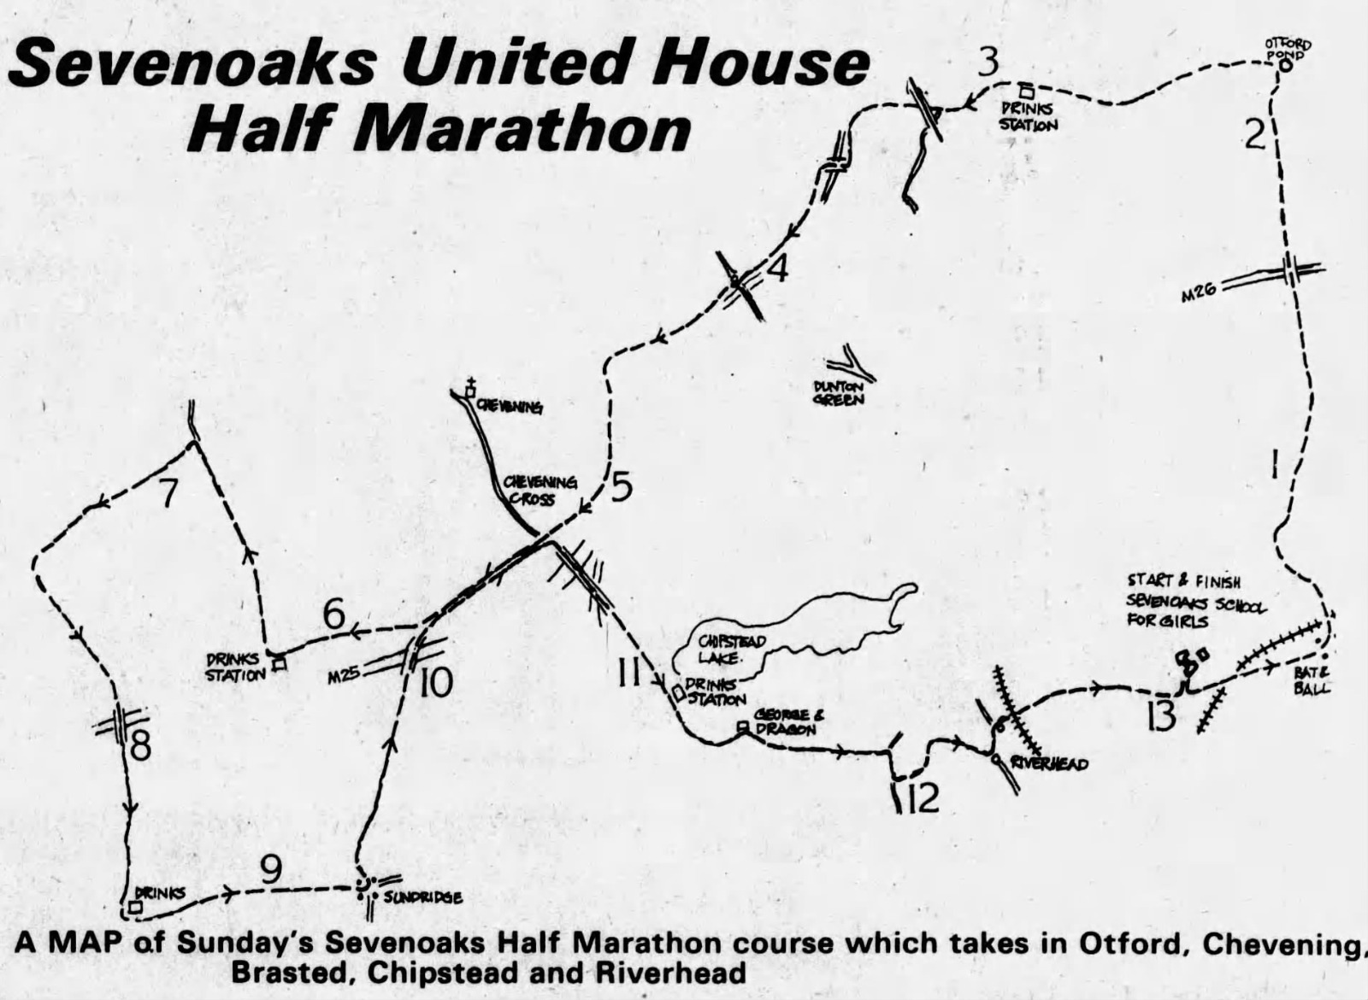
Foot note following the above:
I actually worked for United House from 2013 until 2018; Jeff Adams was still the owner of the company until he sold his shared in 2015 and the company was renamed United Living; I met Jeff Adams on a few occasions and he was always willing to add the company name to local events in town (Summer Festival) and also to sponsor running events such as the Royal Marines1664 Challenge in 2014 when I and Dean Lenihan from Petts Wood Runners ran 60 miles over 3 days instead of sitting at our desks!
Royal Marines 1664 Challenge

Sevenoaks Chronicle 12th October 1989
Great results by Lyndon Collins in 77:52 and Simon Hallpike is 82:02, after 2 hours of car park duty before the race!
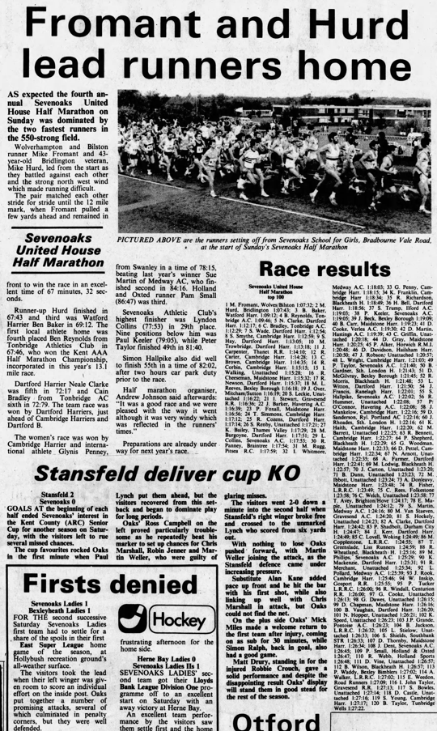
Sevenoaks Chronicle 18th October 1990
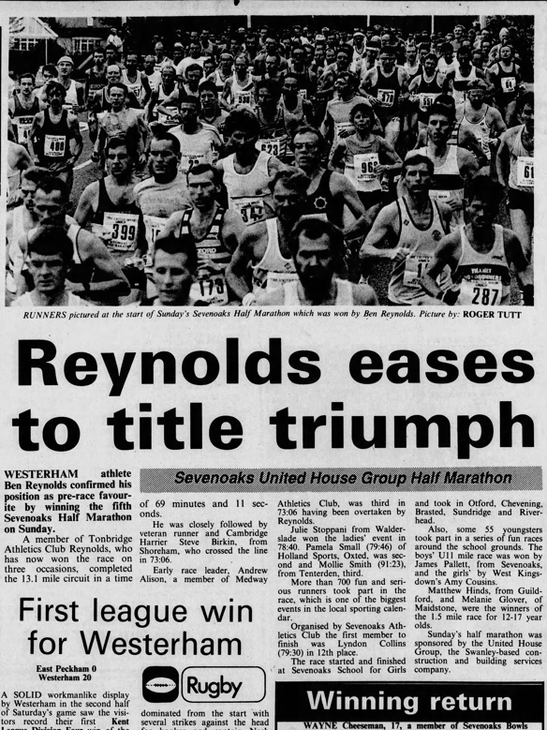

Sevenoaks Chronicle 17th October 1991
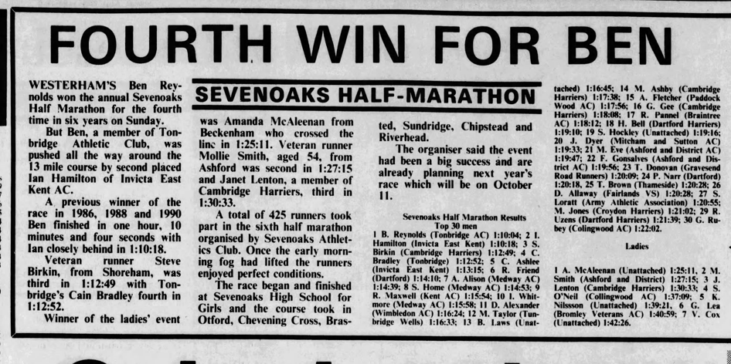
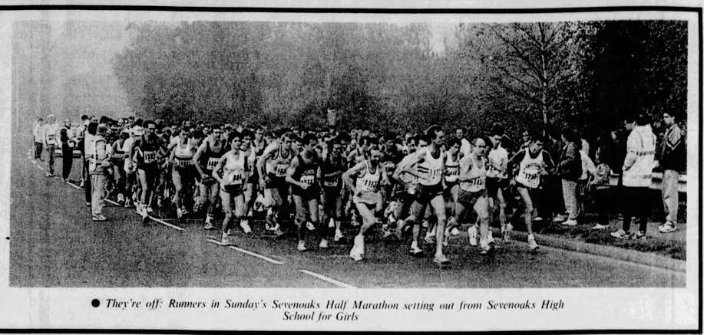
No clippings found for 1992…

Sevenoaks Chronicle 14th October 1993
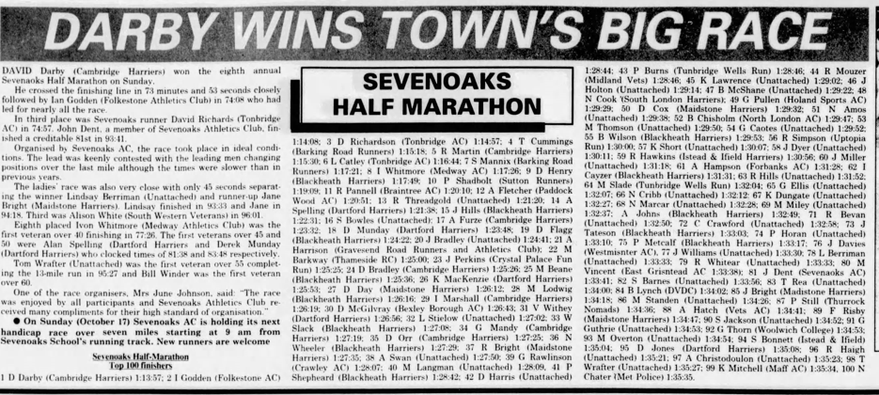
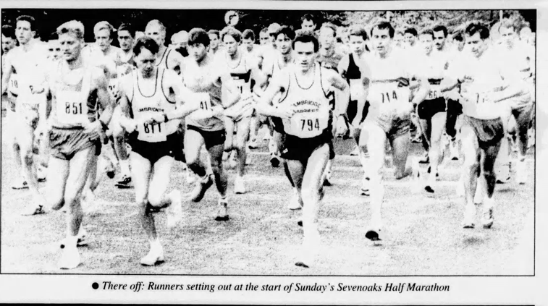
There (sic) off! Wonder who wrote that caption!
Not so many, if any, SAC runners in the results, presumably because they’re needed to organise the race and marshal the route and car parks!
1993 was of course the first year of the 7oaks7, so the Half Marathon’s days were numbered…

